Improving Hypertension Control through Self-Measured Blood Pressure (SMBP) and Tobacco Cessation

Additional Tools and Resources

Tools for Change - Reducing Hypertension in States and Territories
To help achieve the goal of Million Hearts, ASTHO is focused on integrating public health and healthcare efforts to improve hypertension control. ASTHO has compiled tools and resources from states, national organizations, and federal agencies to drive the work of states and territories toward achieving the goal of Million Hearts.
Link: http://www.astho.org/Prevention/Heart-Disease-and-Stroke/Tools-for-Change/

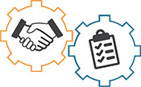
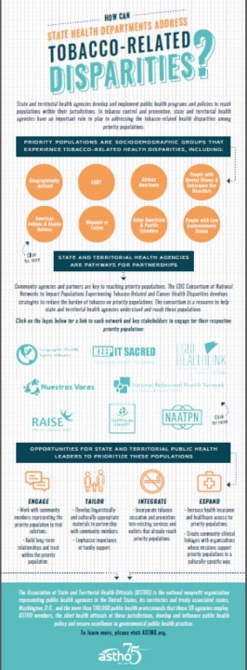
Infographic: How can state health departments address tobacco-related disparities?
State and territorial health agencies develop and implement public health programs and policies to reach populations within their jurisdictions. In tobacco control and prevention, state and territorial health agencies have an important role to play in addressing the tobacco-related health disparities among priority populations. This interactive infographic highlights those priority populations, and offers opportunities for state and territorial public health leaders to prioritize them.
Link: http://www.astho.org/Prevention/Tobacco/Tobacco-Related-Disparities-Infographic/
(Please note: For optimal viewing, it is recommended to open the downloaded PDF from your computer, not through your browser.)

